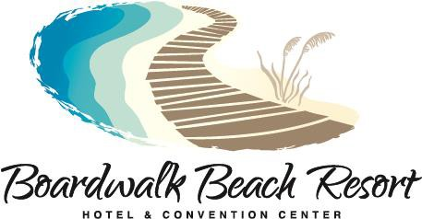

Panama City Gift Show Vendor Charges
The following fees are charged for vendors displaying at the Boardwalk Beach Resort.

QTY
$50 per wireless internet connection by October 12, 2020
$60 per wireless internet connection after October 13, 2020

Electrical Service by October 12, 2020
$75 per 20 amps
$125 per 50 amps

Electrical Service after October 12, 2020
$125 per 20 amps
$175 per 50 amps

T All Electrical Service Orders must be placed and paid for before October 12, 2020. All orders placed after October 12th will be subject to the after October 12th rates listed above.
Please fill out form, credit card number & credit card authorization form for billing purposes and email to Karen.fitzsimons@rabeachgetaways.com

Boardwalk Beach Resort 9600 South Thomas Drive
Panama City Beach, FL 32408 Attention:Karen Fitzsimons

Name: Telephone: Address: City: State Zip: Email: Card Type#
Credit Card # Expiration

Booth #

Company Name: Karen Fitzsimons will be your onsite point of contact, she may be reached at 850-230-4681

